

Blue Tooth 2” Thermal Printer G-8BT2:

APPLICATIONS  THAT  eMPOWER | 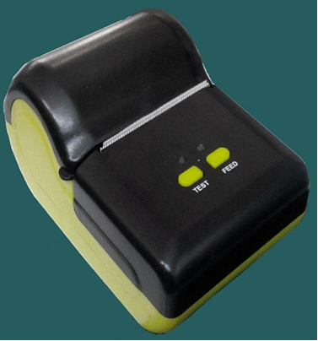

Overview:
G-8BT2 is a mobile handheld blue tooth printer can Integrate with Non OS based devices,OS based devices like android, iOS and Windows etc. The simple user friendly design allows you to operate with easy and light weight and handy. Inbuilt 2 inch thermal graphic printer enables you to print receipt for the transaction. Collected data can be uploaded to a PC via USB/RS-232 serial interface and Blue tooth wireless interface.

Bluetooth 4.0
ARM 32 bit Processor
RS232/USB
2” Thermal Printer

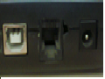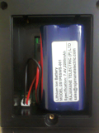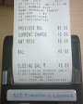

USB & RS232 Ports Battery Compartment Bill Printing

Features:

- Bluetooth printer uses58mmFujitsu FTP-628MCL103#70, which have excellent printing quality with a speed of 75mm/sec.
- Designed for a wide variety of industries that require a cost-effective solution.
- Interfaces: Bluetooth ,USB and RS232.
- Visual LED indication for paper out, Printer cover open, head temperature abnormality Blue tooth Status
- Supports Total 4 fonts. Can be customizable.
- Supports Image and Barcode printing
- Bluetooth Signal Transmission Distance 15M/ outdoor 10M / indoor.
- Supports Low power consumption through dynamic power management mode.
- Provides the highest compatibility with the most of OS available in market.

specification:
Model | G-8BT2
Processor | 32 bit High speed CPU @ 50 MHz
Memory | 64KB Flash memory, 32KB SRAM, 4MB data flash
Printer | 2-inch Thermal Graphic Printer
Print method | Line thermal printer
Paper width | 57mm
Print width | 48mm
Weight ( g) | 235 (not including the paper roll)
Max diameter of paper roll | 40mm
Dot per lie | 384 dots/line
Internal characters | ASCII CH(8x16,9x17,9x24,12×24);
Print speed | 50~80mm/s
Humidity | 95% RH non condensing
Life cycle time | 50km(printing density under 12.5%)/100 million pulses
Text and graphic Support | English, Logo, image , barcode BARCODE128
Dot pitch (resolution) | 203DPI/8 dots/mm
interface | Bluetooth, Mini USB  Optional Wi-Fi, GSM, GPRS and Low power Radio
Power | 2200mAh 7.4V rechargeable Lithium battery
Recharge adapter | Stand by recharging / AC adapter
Self-check | Without paper / cover open
Paper feeding | Easy paper loading
commands | ESC/POS compatible with order sets
Paper cut | By hands
operate setting | Temperature -10°C~50°C ; Humidity 20%~85%
Recharge Setting | Temperature 5°C~40°C; Humidity 20%~85%
Storage Setting | Temperature -20°C~70°C ; Humidity 5%~95%
Standard accessories | Paper roll ,AC adapter, USB cable
Optional accessories | Serial interface cable/leather coat/CD

Functional Specifications:
- Test Print Function
Item | Description
 | After pressing “TEST” Switch the following contents will be print:
 |  | - GVM Electronic Systems
 |  | - Printer Driver card
 | . | - Test Print
 | . | - Supports four fonts
 | . | - Font 1
 | . | - 0123456789
 | . | - abcdefghijklmnopqrstuvwxyz
 | . | - ABCDEFGHIJKLMNOPQRSTUVWXYZ
 | . | - Font 2
 |  | - 0123456789
Test Print | . | - abcdefghijklmnopqrstuvwxyz
Function | . | - ABCDEFGHIJKLMNOPQRSTUVWX
 |  | - Font 3
 | . | - 0123456789
 | . | - abcdefghijklmnopqrstuvwxyz
 | . | - ABCDEFGHIJKLMNOPQRSTUVWX
 | . | - Font 4
 | . | - 0123456789
 | . | - abcdefghij…
 | . | - ABCDEFGHIJ…
 | . | - Image print support
 |  | - “Image”
 | . | - Barcode print support
 | . | - “Barcode”
 | . | - Barcode Number 5512345
 | . | - Test Print completed

GVM Electronic Systems.

Registered office:  502, Sri sai land mark, Block-A  Street No-8,Habsiguda  Hyderabad - 500007,  Telangana (INDIA).  Website : www.gvmgroup.co.in |  | R&D Center:  1-7-9/3, Level 1 Harihara Estates,  Opp ISI, Street No. 8,Habsiguda,  Hyderabad - 500007  Telangana (INDIA).  Tel : 040 – 40073218.

